* 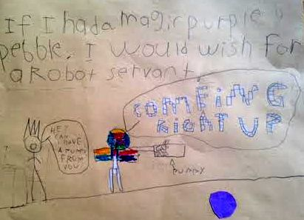
* **What device wakes you up in the morning?**
* No device, no alarm. My mom, she pats me awake. Sometimes, I try to take a power nap before I actually get up and go to school.
* **Are you the inbox-zero type when it comes to email?**
* Since I am 6 years old, I am not allowed to have my own email account.
* **How do you communicate with adoring relatives who live far away?**
* I Skype with them. I also have other fans and followers. They are online.
* **You have a favorite website?**
* Oh yes– that **HAS** to be [scratch.mit.edu.](https://scratch.mit.edu/)
* I create my own games there. I put in a lot of 3D effects. They are multiplayer games, so my friend Isaac can play with me.
* You should go to my game “CAPTURE THE FLAG” and favorite it. I keep creating new ones all the time.
* **I will favorite them all! Tell me, what’s one gadget you cannot live without?**
* My iPad, of course. And it has to be 100% charged when you hand it to me. Not 97% or 98% -- it is just not the same thing. I don’t get mad if it’s less than 100% but…
* **Hmm ... OK. How do you unplug?**
* I prefer not to. But there are times when I am grounded – that means no iPad/TV/computer.
* **Where do you to watch your favorite shows?**
* I watch my favorite shows on television. My favorite channel is the Cartoon Network; my favorite show is Teen Titans Go. When I am grounded, I try to get my sister’s iPhone and watch my shows.
* **What was the last tech tool you became a fan of?**
* Amazon's Echo.  Alexa – she plays my favorite songs for me.
* 1. BREAK MY MIND
* 2. FIVE NIGHTS AT FREDDY’S
* 3. ITS TIME TO DIE
* 4. IT’S ME
* I also ask Alexa some math questions: like this problem 312+312. I know the answer is 624, but I ask just to make sure.
* Sometimes I ask her stuff like “How big is your butt?” but she doesn’t answer those questions.
* **What is your favorite toy?**
* [MIP, the balancing robot](http://www.wowwee.com/mip/). I could control it with my dad’s cellphone. One time, I made it go right up to my neighbor’s house and knock the door. Now, the toy won’t work. We changed the battery, but it still won’t work.
* **Sorry to hear that! Heard any good jokes lately?**
* Oh Yes! "Yo' mama is so stupid, she went to the dentist to get a blue tooth."
* **What’s on your tech wish list/what do you want Santa to bring you?**
* Alexa helped me make my list for Santa. What’s on it, so far:
* XBOX1
* [MIPOSAUR](http://wowwee.com/miposaur/)
* I will be adding more stuff close to Christmas.

You can check again with me later.

I would also wish for a robot servant.